-------------------------------------------------------------------------------------------------------------------------------NAME: ARCHANA DEVI.P
REG NO: 192521192
COURSE: SOFTWARE TESTING
CODE: CSA0923
LAB PROGRAMS

29. Convert Temperature from Celsius to Fahrenheit
Aim
To write a Java program to convert temperature from Celsius to Fahrenheit and verify the output using white-box testing.
Algorithm
- Start.
- Read the temperature in Celsius.
- Pass the value to the conversion function.
- Calculate the Fahrenheit temperature.
- Display the result.
- Test different input values and verify the output.
- Stop.
Program: TemperatureConverter.java

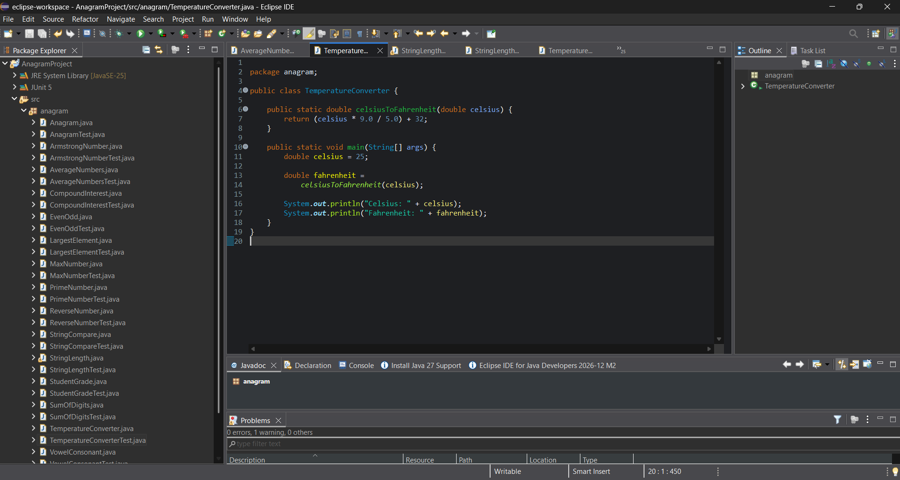 White-Box Testing
Test the calculation with different values.
Test input (°C) | Expected output (°F)
0 | 32
100 | 212
-40 | -40
25 | 77

Example code:
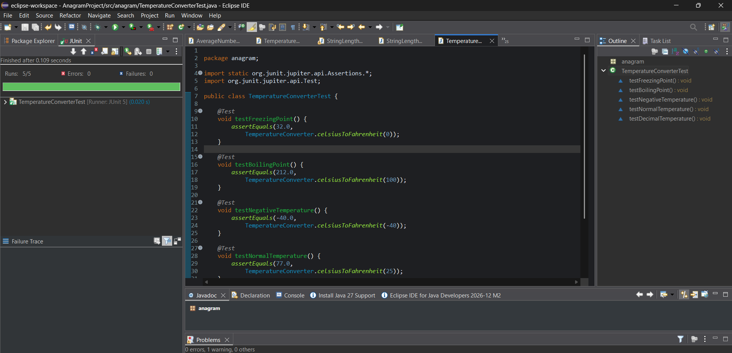 White-Box Testing Explanation
- Verify that the conversion function executes for each input.
- Check the multiplication, division, and addition operations.
- Test zero, positive, and negative temperatures.
- The program has no conditional branches, so testing focuses on the calculation and different input values.
Result
The Java program to convert Celsius to Fahrenheit was implemented successfully. The calculated output values can be verified using white-box testing.

